- Launch one aws ec2 and install jenkins.
First, we create an AWS EC2 instance.
Then we set up a SSH password-less login for ease.
Use GitBash to connect to the instance using ssh. - ssh ec2-user@publicip.
Next, we download the jenkins repo file using : sudo wget link
Dowload the jenkins gpg key using : sudo wget -O /etc/yum.repos.d/jenkins.repo https://pkg.jenkins.io/redhat-stable/jenkins.repo
Then we import the key : sudo rpm --import https://pkg.jenkins.io/redhat-stable/jenkins.io.key
Then we install Java on the instance using : sudo yum install java-11-openjdk-devel -y
Check after installing by : java –version.
Then we install Jenkins : sudo yum install Jenkins -y
Enable Jenkins : sudo systemctl enable –now jenkins.
Now we get Jenkins initial password : sudo cat path to file.
Open browser and type http://yourpublicip:8080.
Install suggested plugins.
DONE!
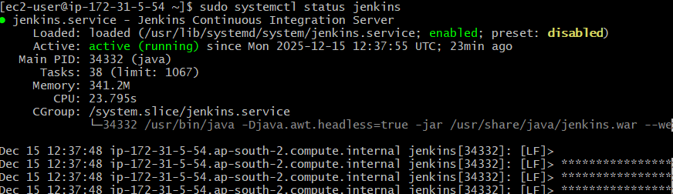
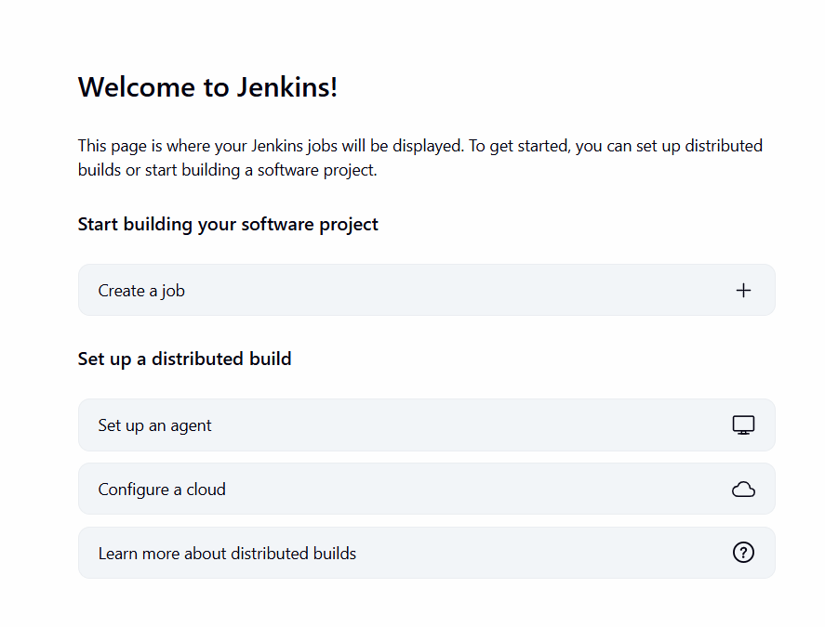
- Setup Apache Tomcat on Ubuntu Virtual Machine. - - - - - - - -
First, we install java on our virtual machine, Ubuntu.
Then we download Tomcat using : curl -O link.
Then we install Tomcat into /opt using: sudo mkdir –p /opt/tomcat and extract using tar command
Then we create a tomcat service file.: sudo vi path to tomcat.service.
Then paste the service file from the internet in it.
Now enable tomcat using systemctl command and then start the service using systemctl command.
Check the status : systemctl status tomcat
Got to the browser and open http://yourserverip:8080.
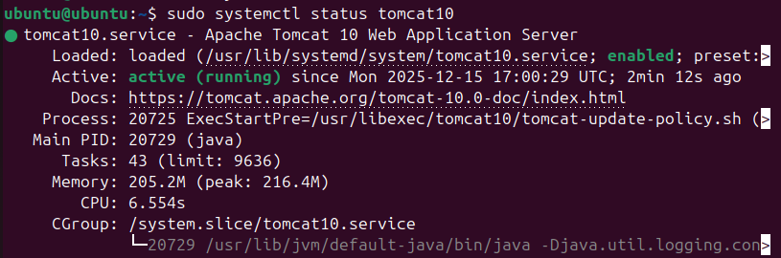
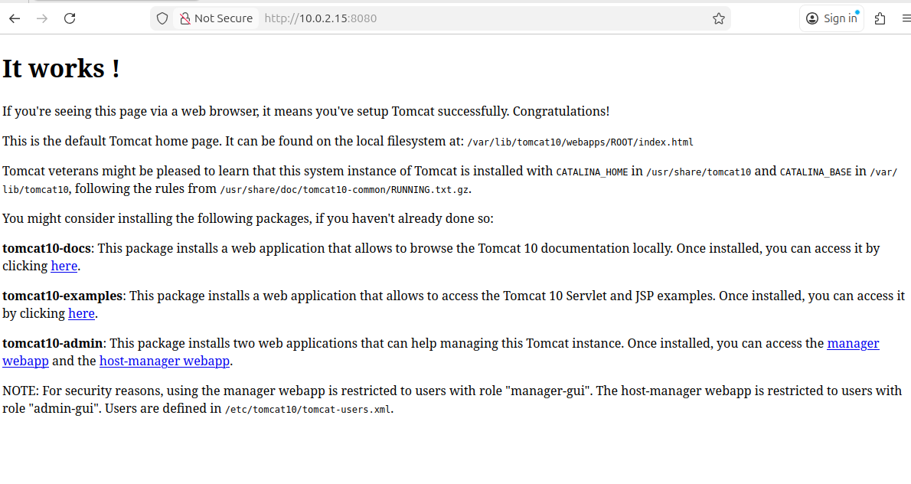
- Setup Docker Desktop on your local windows
